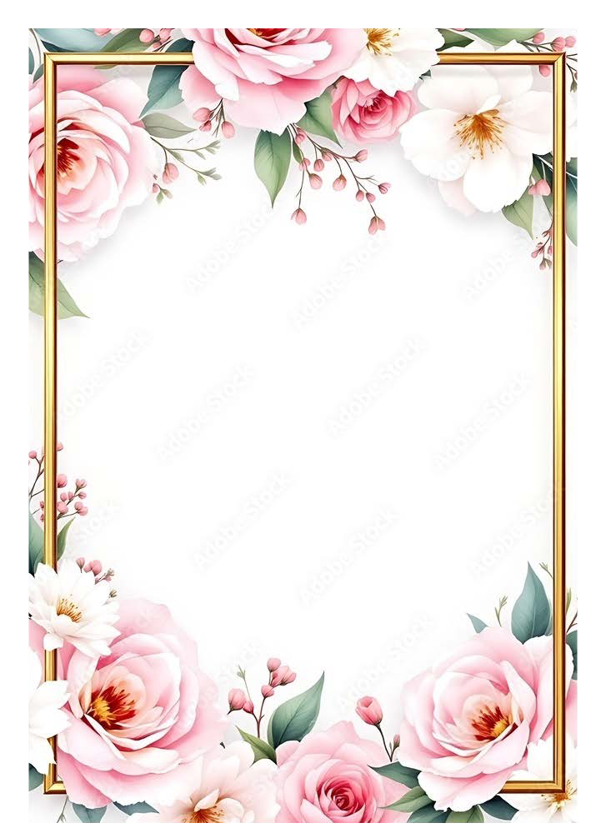

Petals Nov 2025 mfgc.jeanniebennett@gmail.com Hello and Happy Fall to everyone.
This Petals is sent to all members of the Board of Directors for MFGC. Occasionally someone extra is added as the official correspondent for a club. There are 3 purposes to this Petals:
- I have attached the new update for The Awards Handbook in a PDF format. It is ready to print using whatever settings you have for PDF documents. The Awards Application Form is in a DOC format. It is revised to make it easier to separate the cover sheet from the detailed application. You can make plenty of copies and easily space your application materials. These are posted on the AWARDS section of the website. We hope all club presidents will share with their awards chairperson and members.
- For your info, the Flower Show Judges list is updated with the current list of certified Flower Show Judges available for helping with and judging your club flower shows. This is posted in the Judges Council section of the Website.
- We will resume having a No Cost to clubs Zoom page in December. More information will be sent as soon as the purchase is final.
- The Treasurer, Bev Geary, has sent the award renewal letters to everyone who will need to make a deposit on their sponsored awards. If you as a club or individual wish to increase the award, simply send her the amount you desire. To change wording please send the request to me, mfgc.jeanniebennett@gmail.com. For other award specific questions please contact Cindy Carlton, cdcarlton@hotmail.com.
We hope you have a pleasant Thanksgiving and enjoy reading the Montana Gardens before the mass influx of gardening and seed catalogs hit your mailbox.
Sincerely, Jeannie Bennett, 406-781-7615 Stop and smell the flowers!

