Director's Award
Award of Excellence Project for Regions
NGC Award #25

Margie Soileau, Project Chairman

RMR Awards
.
SOILEAU BY-648-Award 1 Colorado Award -- Garden Therapy
This may be a single garden club or group of garden clubs that have sponsored a project such as any of the following:

a. Includes gardeners with different abilities or senior citizens
b. Teaches gardeners with different abilities or senior citizens,
c. Provides a service to a group of people, or
d. Programs and activities for barrier-free gardening.

Award 2 Kansas Award — Conservation
This may be a single garden club or group of garden clubs that have sponsored a project such as any of the following

a. Educational activity or program,
b. Legislative activity,
c. Conservation project (wildlife refuge, watershed protection, etc.)
d. Work by an individual (may or may not be a garden club member),
e. Comprehensive program in environmental education
f. Bird (such as establishing sanctuaries, promoting law enforcement, etc.)

Award 3 Montana Award — Writing
This award is open to a garden club member, garden club, group of garden clubs, or a member state for publications such as:

a. Garden Club Yearbook
b. Garden Club Scrapbook
c. Garden Club Newsletter
d. State publication
e. Articles for publication by a magazine or newspaper (full article must be submitted)
f. Books relating to horticulture or gardening
g. A non-garden club member who has published a book on horticulture or gardening
h. Any design publication, (NGC calendar or other) by garden club member (e.g., Vision of Beauty calendar).

Note: Yearbooks are due August 15 for the yearbook award. Yearbooks will not be returned but retained for the NGC Yearbook Award. Other yearbooks will be considered if received by January 1 to the RMR Awards Chair for the NGC Yearbook Award.
Award 4 Nebraska Award — Horticulture Excellence
This award is open to a garden club member, garden club, group of garden clubs, or other individuals for projects such as:

a. Contributions to horticulture through research
b. Contributions to horticulture through education
c. Contributed to horticulture through a project.

Award 5 North Dakota Award — Video/CD/DVD/Flash Drive/Slide Shows
This award may be given for the best video/CD/DVD/Flash Drive production on any State, RMR or NGC objective as listed below:

a. History/Archives
b. Garden Tours (private)
c. Garden Tours (public)
d. Flower Shows
e. Projects
f. Programs
g. Other

Award 6 South Dakota Award — Birds
This may be awarded to a garden club member, garden club, group of garden clubs, or other deserving individuals or groups for projects such as:

a. Comprehensive and effective program of protection,
b. Educational programs
c. Design, installation, and maintenance of public or private gardens.

Award 7 Wyoming Award --Trees
This award may be given to a garden club member, garden club, group of garden clubs, or other deserving individual or groups for projects such as:

a. Planting the greatest number of trees
b. Educational program regarding the importance of trees
c. Design, installation of a public arboretum
d. Volunteering in a public arboretum

Award 8 Utah Award — Garden Tours
This award may be giving to a garden club member, garden club, group of garden clubs, or other deserving individuals or groups for project such as

a. Open to the public
b. Partnered with another group
c. Open to garden club members only
d. Garden that has been on public display
e. Tour of garden club members’ gardens

Award 9 June Johnsrud Membership Award
Application is not required. State Membership Chairman will submit information to the RMR Awards Chairman.

a. To the State Garden Club showing the greatest increase in paid memberships during the past fiscal year, or
b. To the State Garden Clubs showing the greatest per capita increase in paid memberships

Award 10 Civic Development
This award may be given to a garden club member, garden club, group of garden clubs, or other deserving individuals or groups for project.

a. Project must make permanent improvement to a community
c. Project which makes permanent improvement to a historical site
d. Project that makes permanent improvement to a public building such as a church, courthouse, or school
e. Project that has been ongoing for several years
f. Outstanding community outreach program

Award 11 Conservation and Environmental Concerns
This award may be given to a garden club member, garden club, group of garden clubs, or other deserving individuals or groups for projects such as:

a. Educational or legislative activity program by a club or group of clubs
b. Outstanding work by an individual member of a garden club
c. Most recycling efforts,
d. Garden club project that promotes conservation
e. Garden club project that promotes an environmental concern
f. Project that incorporates wildflowers or native plant materials.

Award 12 Butterfly Gardening
This award may be given to an individual, club, or group of clubs for a butterfly garden for projects such as:
a. Small area — less than 1,000 square feet

a. Open to the public
b. A private garden
c. A garden funded by a non-garden club entity
d. A garden funded by a garden club or group of garden clubs
e. Designed by a garden club or group of garden clubs

Award 13 Flower Show Awards
This award may be given to a garden club member, garden club, group of garden clubs, or other deserving individuals or groups for sponsoring a Flower Show. A Book of Evidence up to 6 pages indicating all the show divisions and sections.

a. NGC Standard Flower Show
b. Non-NGC Flower Show

Award 14 Landscape Design
This award may be given to a garden club member, garden club, group of garden clubs, or a RMR State Garden Club for projects such as:

a. Projects that make a significant contribution providing planning and/or planting in a facility such as church, park, library, hospital
b. Outstanding program of continuing landscape design education

Award 15 Garden Study
This award may be given to a garden club member, garden club, and group of garden clubs, or RMR State Garden Club for projects such as:

a. An educational program that is open to the public
b. A single program that promotes the objectives of the Garden Study Council

Award 16 Youth Awards
This award may be given for outstanding achievement in the following areas:

a. A junior, intermediate, or high school club that a service to their school
b. A leader who has given outstanding service to a youth club
c. Youth club project that promotes planting and growing in outside area
d. Youth garden club for the most comprehensive program in the field of environmental concern, landscaping, antilitter, etc.

Award 17 Fund-raising
This award may be given to the club, group of clubs, or a RMR State Garden Club for creative and unique fund-raising ideas.
Note: The RMR Chair will collect fund-raising ideas, print and distribute at the RMR Convention for possible use by our members.

Award 18 Blue Star/Gold Star Highway Memorials
A Certificate of Merit will be presented to those clubs or groups on clubs that have installed a byway marker or highway marker.
Award 19 Rocky Mountain Region Projects
This award may be given to a garden club that does an exceptional project to promote and participate in RMR goals with special activities.

Award 19 Rocky Mountain Region Projects
This award may be given to a garden club that does an exceptional project to promote and participate in RMR goals with special activities.

Award 20 Special Achievement Awards
This award is for outstanding garden club work by:

a. Individual
b. Garden club
c. Group of garden clubs
d. Non-garden club individual group

Award 21 Award of Excellence for Regions
A certificate shall be awarded to each member State Garden Club for the National Award of Excellence. Each member State Garden Club shall be recognized at the Awards Banquet at the RMR Annual Meeting in the odd numbered years. Recognition is by the RMR Award of Excellence Chair for Regions. In addition to a certificate, a monetary award may be awarded to the two largest and two smallest member states which have submitted outstanding Books of Evidence for their work, as well. No application is necessary for this award.

Award 22 Citation of Distinguished Service
The Rocky Mountain Region Director shall present a Citation of Distinguished Service to any member who has provided notable achievement and guidance. Write an article and send to Award Chairman in lieu of application.

Award 23 Club Programs
This award may be presented for a garden club program(s) on growing, studying and the culture of plants or a plant family. Program(s) must show descriptive detail so the program may be used by other clubs.

Award 24 Youth Gardening
This award may be given to a club for a project that involves either horticulture or design activities for Youth. The award application should clearly state the ages involved.

Award 25 National Garden Clubs Project
This award may be given to a garden club that does an exceptional project to promote and participate in NGC goals with special activities.
Award 26 Photography - Camera
This award may be given to a garden club member whose photo or group of photos (no more than 5 photos) depict the following themes:

a. Conservation of Flora and Fauna
b. Wildflowers
c. Creating Butterfly Habitats
d. Promoting the Social Bees
e. Birds

National Award for Regions
Member Award of Honor
Awarded to one member in each region whose volunteer efforts during a period of five or more years, has made outstanding contributions to club and community, in one or more of the following areas: civic development, horticulture therapy, youth activities, conservation, landscape design, horticulture, floral design, or all-around excellence. Eligibility: any member of a State Garden Club, who has never been a member of the NGC Board of Directors. Eligibility and Rules listed on NGC Website, www.gardenclub.org , “Awards” – Member Award of Honor. A book of evidence should be submitted not to exceed 3 pages. Obtain state’s deadline date. State Awards Chairman forwards one entry to Regional Awards Chairman by February 1. The eight Regional Winners will receive a NGC Certificate and a pin at the NGC convention. They will be recognized in The National Gardener.

HIGH SCHOOL DISTINGUISHED SERVICE PROJECT
Youth Award #76
Bringing gardening and our youth together is an exciting process and can be fun for parents, grandparents, or other adult friends.
The High School Distinguished Service Project Award along with $100 for first place and $50 for second place may be awarded to a high school student, grade 9-12, for an outstanding civic project making a significant improvement for public benefit, e.g., environment, conservation, landscape, horticulture, recycling, horticulture therapy, etc. Single member club, group of member clubs, districts or a state garden club must sponsor the contest. Reach out to youth groups already formed or classes at school. Our youth have been exposed to many different types of gardens. Those that prove to be the most successful are those that relate to their experiences. If you know of someone who has done an outstanding civic project consider applying for Award #76, High School Distinguished Service Project under Youth Awards.

Youth Sculpture Contest
Encouraging Youth to Keep Our Planet Green
Purpose To encourage youth to keep our planet green and to get involved with saving the environment.
For more information, contact: Terry Critchlow, Chairman: Youth Sculpture Contest

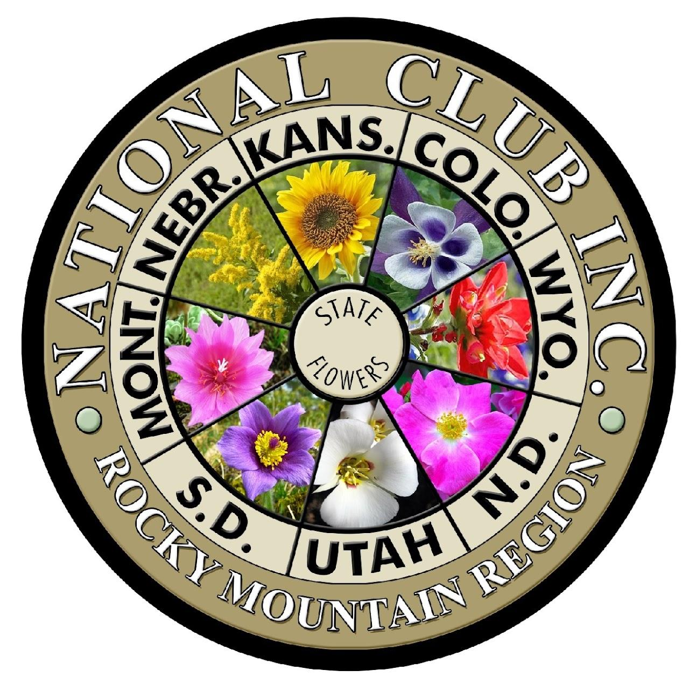
Website administrator: Carla Scheer
Questions or concerns about our website? Please contact us at rockymtnregiongardenclubs@gmail.com.

