Montana Federation of Garden Clubs
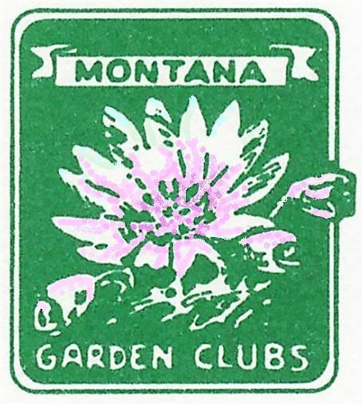

Speaker’s Bureau—Program Presentations
Please contact Diana Raymond to make additions/corrections
P.O. Box 985 Shelby MT 59474 (406) 450-8397 dkraymond5@gmail.com

All Accredited Judges Refer to MFGC Directory Flower Design and Horticulture Topics, How to Create a Flower Show
Jim Sadler, Missoula jimsadler@bresnan.net Roses, Iris, Dahlia Presentations 728-4743
Create flower show schedules; floral design

Patrick Plantenberg, Townsend m2andp2@mt.net
Edible wild plants; Xeriscaping; 266-5265 [call at least 60 days Landscaping with Native plants; Trees for Public Areas; before program need]
Getting the Community Involved in Projects; Landscaping—Installing Specific Projects in the Community for a Training Exercise, i.e, installing edging, using fabric, mulches; Wildflower/Edible Plant Walks and/or Cooking
Darlene Skari , Chester, Great Falls dskari@3riversdbs.net Cooking from the Garden, 292-3602
Beginning Vegetable Gardening

Norman DeNeal, Butte normanjdeneal@gmail.com Twelve favorite plants, Roses for Montana 723-6656
Starting plants from seed

Phyllis White, Bozeman gardens@bresnan.net Growing succulents; Horticulture Therapy, 586-0400
Publicity, Fundraising, Building Partnerships

Denise Fink, Billings fink52daf@gmail.com
Landscape Consultant; Pruning Trees and Shrubs; 939-0957
Plant Growth and Development; Plant Nomenclature; Soils; Anatomy of Plants; Starting Plants from Seeds
Susan Andrews, Bozeman sugar30@lat.com Montana wildflowers 582-4135
Hillary Maxwell Maxwell.hillary@yahoo.com
Lasagna gardening 357-2727
Yard tour of farm east of Chinook

H. G. Robinson House & Bird Sanctuary, Malta Highway 2, Open 7 days a week Tour the Impressive gardens featuring Heirlooms 654-1037

Dennis Linghor dennis@americanprairie.org Plants growing on the prairie near Malta (tour) 654-1647
Alana Hastings hhastings@3riversdbs.net Abstract flower artist 866-3270
Larry Adams, Havre 265-9790
Lawn and tree care specialist
Charles Carlson, Nashua chuckcmt@nemont.net Audubon Society Member 526-3245
Coordinates Christmas Bird County for MT
Bill Lauckner, Nashua lauckner@nemont.net MT Mountain Bluebird Assoc. Founder 785-4651
“How to Attract Birds to Your Backyard” Conducts Bluebird trail tours from May-June
In Nashua-Ft. Peck area
Carol Works, Big Sandy 378-3163
Starting a garden from seed Gladiola growing expertise
Loy Cvilicek (sounds like shivilicheck), Havre loyann@bresnan.net “The Language of Flowers” 449-1394
(Victorian flower gestures)
Elizabeth McClain, Scientist in Harlem acquaticstudy@hotmail.com “Seed Banks of the World” 353-4248
“Colony Collapse of Bees”
Bob Ford, Great Falls Master Gardener bobthegardener@greatfallsace.com “Low Maintenance Gardening” 217-3455
Growing Seasons, Companion Gardening, Crop Rotation, Harvesting Your Crop
Don Hazen, Ft. Benton adhazen@mtintouch.net Florist—trained with Junne Johnsrud 622-5241
Landscape designer and Perennial garden expert
Patti Simons, Hi-Line Florist 379-2363
Succulents, Growing in Tough Conditions
Dan Sullivan, Helena dsullivan01@bresnan.net Ornithologist, Native plant expert 443-4229

John Stroud, a/k/a “Johnny Bitterroot” P O Box 638
Very fine program on Bitterroots Stevensville, MT 59870-0638 406-777-5054
Megan Terry Water & Environmental Technologies-WET Lawns, landscaping Moonlight Professional Building
480 East Park Street, Suite 200
Butte, MT 59701
(406) 782-5220; Direct: (406) 497-8688;
Fax: (406) 723-1537
Shayne Galford 1629 Ave/ D/. Ste A-5
Plant Health Safeguarding Specialist Billings, MT 59102 Invasive Insects in Montana 406-657-6282
Shayne.p.galford@aphis.usda.gov

