PETALS IN THE WIND
  - NEWSLETTER Jim Sadler, editor
Save the Date for the June 10 to 11 convention in Missoula at the Holiday Inn located downtown Missoula. Those who have attended before at this location will remember the Farmers Market that occurs on a side street by the Hotel. Folks get up early Saturday to do a little shopping. Crafts, lots of plants, and wonderful sticky buns are available.
Below is a photo of Jim and Linda’s Sadler’s house in June Photo by Linda Sadler
T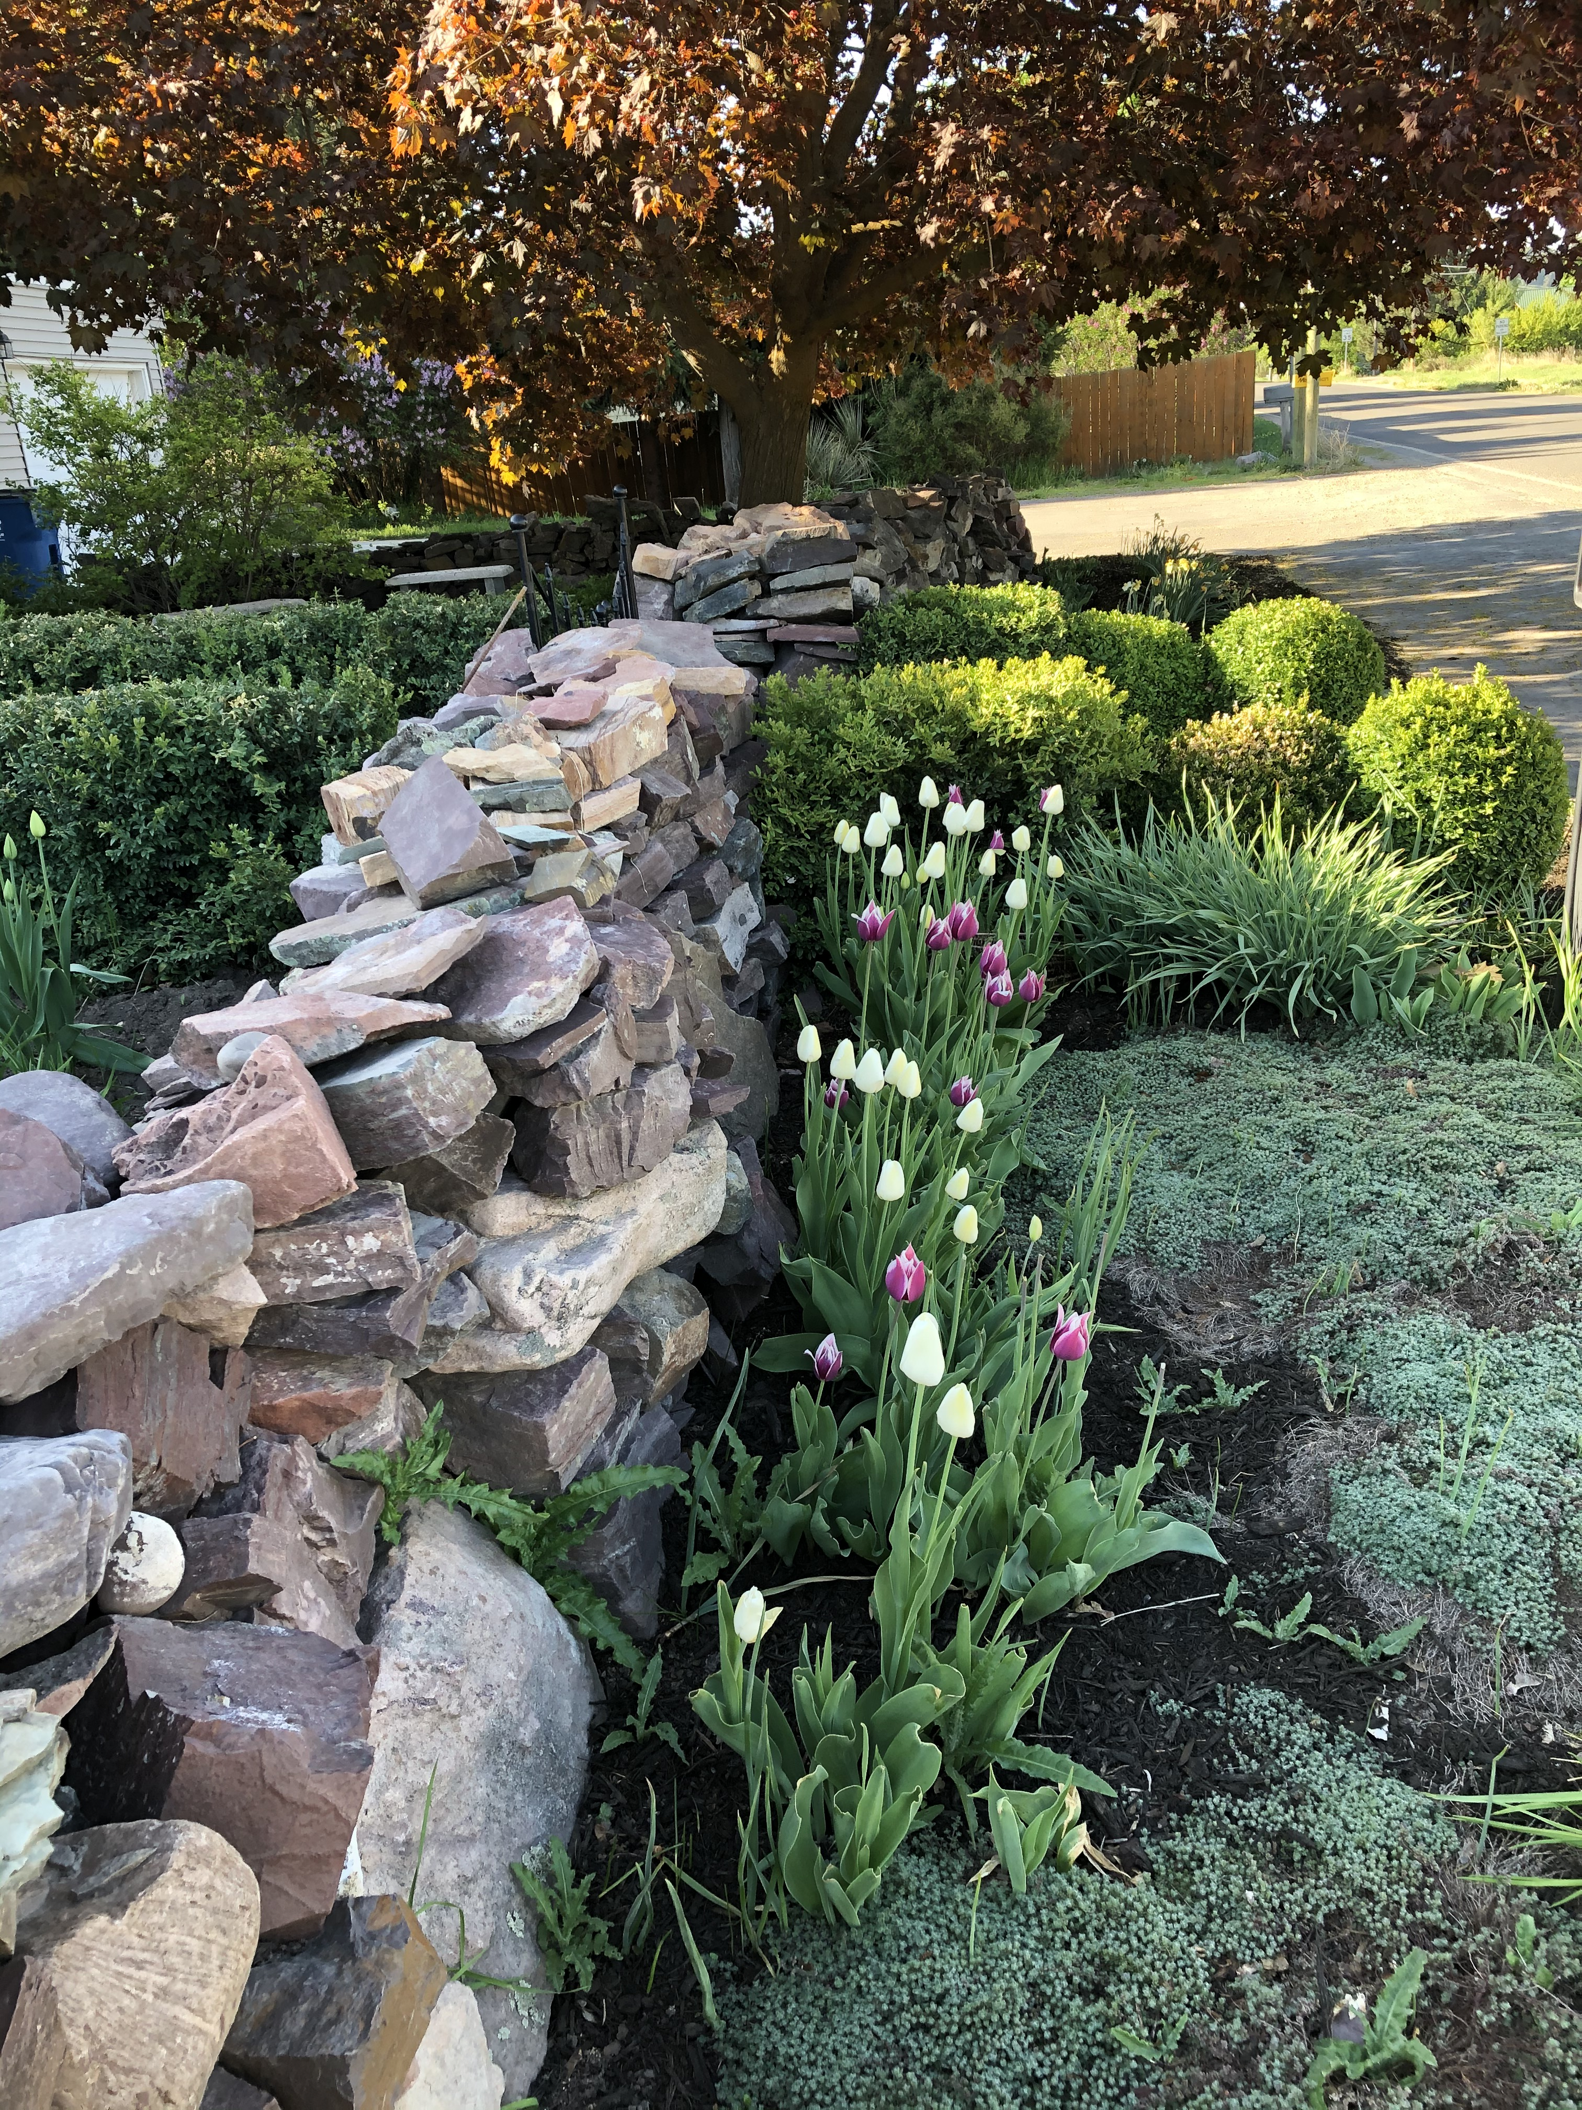
MTFGC.ORG  CLUB Website Needs to be updated soon  I have contacted most of the presidents that have an email address asking them that they should go to MTFGC.ORG and check out their clubs listing. Folks need to make sure their club is listed correctly with current officers and program dates. Contact Elaine Wood at mfgweb@gtfalls.com. Send her the information and she will do the posting. Easy Peasy  Clubs should understand that the website is the face that our organization has to the world. Those who never search the internet may think keeping the website posted as not necessary. We are in a new age now. Like it or not the way folks seek information is on the internet. I just got a phone book the other day in the mail. I asked Linda where should we put it? and she said “throw it away” If she needed a number she would just google it. See the point! | mtfgc.ORG FACEBOOK PAGE  Contact Mary Wambolt at fmwambolt@midrivers.com to post pictures of your club’s activities. Be sure to like the mtfgc.org Facebook page. Some clubs are receiving new members by inviting folks on their page. The page is an effective way for clubs to keep in contact. We can cut down on our isolation by taking advantage of what is available.  I have friends who tell me that they never post anything on Facebook. Worry about safety, hacking, and troublesome political posts are not wanted. My response is that one just must be careful who you friend. Make sure only people you really care about can see your posts. If the club is posting then only club matters such as pictures of projects, buildings, floral designs, horticulture exhibits are all good candidates for pictures on Facebook. Keep off personal information and messages and you will not go wrong. | DISTRICT DIRECTORS NEED TO CHECK ON CLUBS  District Directors are the glue that binds our districts together. Planning is in the works for meetings in April. District Directors should be in contact with your clubs and 1st Vice President Diane Ward at mydoubleheartranch@gmail.com. to plan the meeting and the time. Dates are very sensitive, and compromise should be considered. Last year the meetings were fun filled and special. The traveling flower show was informative. If you have any ideas of what you want from f the officers now is the time to suggest them.  The District Meetings are organized by the clubs in the district. As such the meeting can be anything you want. A lunch with a program is satisfactory. I have seen skits that are so funny I almost forgot to breath. The personality of the clubs is what is show cased. It is a time to have fun and enjoy each other’s company. The officers come because we want to meet you on an individual bases. Make sure we have plenty of time to enjoy each other’s company.
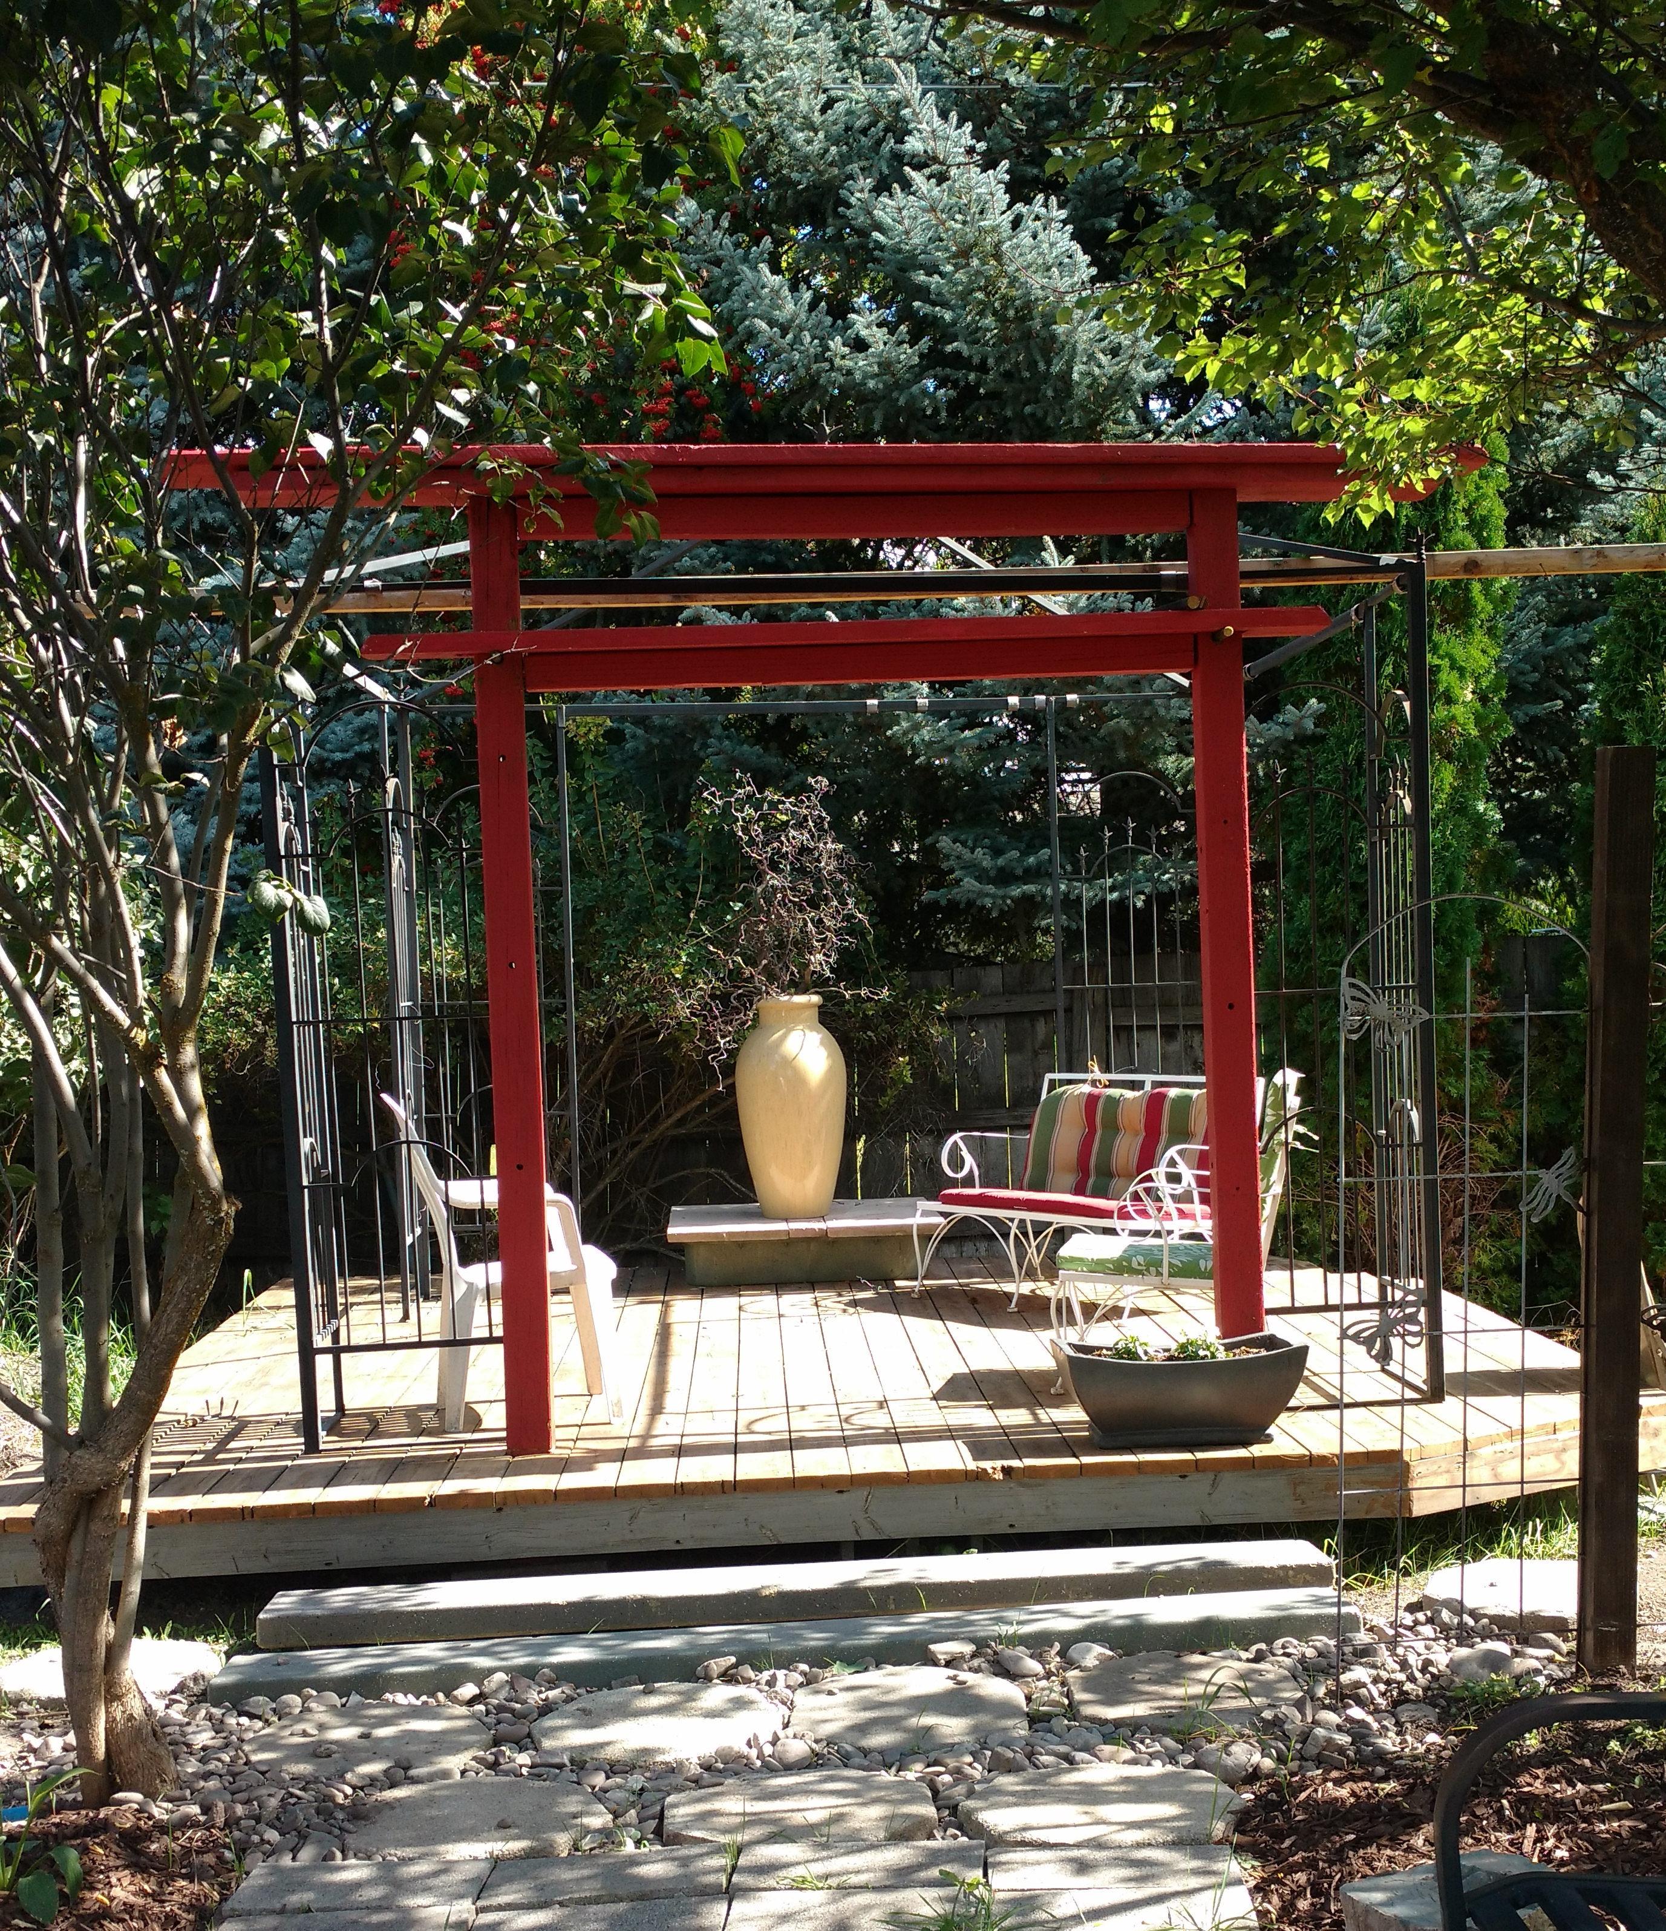

Linda and Jim’s tea house in June. the site will be featured at garden tour June 12th champagne will be available here for the tour participants
Photo by Linda Sadler June 2021

Remember the saying “times are a changing”. Another change is the need to seek permission of every person that you use in a photograph. My assumption is that it is the result of the litigious age we find ourself. The National Garden Club has a form now that we need to send in that requires permission from every person included in a photograph. Jim Sadler, President, Montana Federation of Garden Clubs, Inc. | 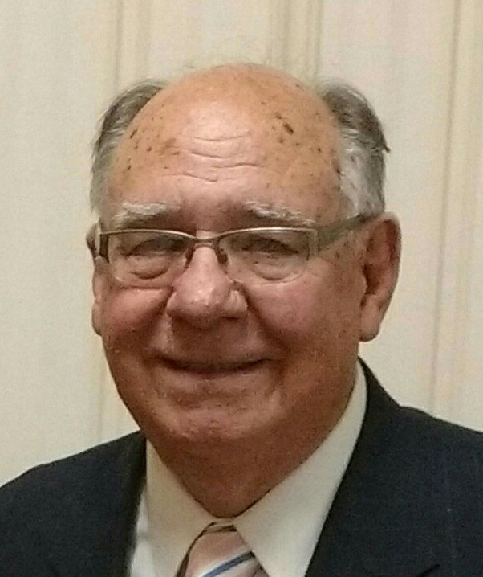
Every time a photo is published permission must be obtained from every individual in photo Officers are developing montana picture permission document | The Finance Committee has been referred the issue to work out a plan for MFGC to enable our organization to use photos with ease.

Officers are developing montana picture permission document

Jim Sadler proposed at a recent Executive meeting that MFGC should adopt a policy that would require State registration form for dues would include language that would give permission to use members photo in any photo sent to MFGC. This will expedite the permission process. That is by joining the club the member is giving permission to use the persons likeness. In this way individual permissions do not have to be obtained every time a picture is taken containing people. The process will be to refer to the Finance Committee as this is their jurisdiction. If they recommend, then the matter will come before the convention

A view of the path through the pillars towards the back rose garden and peony garden. Photo taken by Linda Sadler in June 2021
