GOLD STAR DEDICATION CEREMONY
Submitted by Jo Lee Burman
On Sunday, September 27,2020, National Gold Star Mother’s and Family Day, the Dearborn Garden Club along with American Legion Post 133 dedicated the Gold Star Families Byway Marker. The ceremony took place at the Legion’s Hood-Mortag Memorial Wall. A crowd of about fifty attended the ceremony. The dedication was emceed by Colleen Mason, past President of the Dearborn Garden Club. The Ceremony began with an invocation given by Pastor Mark Nelsen of the Canyon Life Church and the presentation of colors by the Malmstrom Air Force Base Honor Color Guard. A history of the Gold Star Families Marker was given by Kathy Austin, MFGC Blue Star and Gold Star Families Marker Chairman. Lt. Col. Mike Milburn, retired USAF and former State Representative, gave a heartfelt tribute to the Gold Star Families. Leslie Stafford, a Gold Star daughter, unveiled the marker following the tribute. After the unveiling, Jo Lee Burman, Dearborn Garden Club President, dedicated the marker. Lewis Thoenes, Commander of the American Legion Post 133, accepted the Gold Star Families Marker for Post 133 and placed a wreath at the Marker. Father Cory Sticha, Priest at the Sacred Heart Church, gave the benediction. The ceremony ended with Mr. Jeff Skogley, Cascade High School music teacher, playing Taps. Refreshments followed at the Cascade Senior Center.
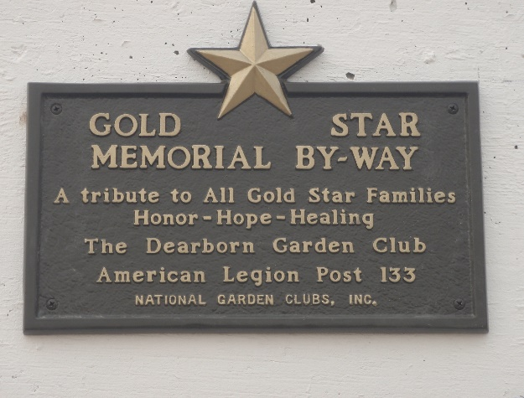
The Gold Star Memorial Byway Marker

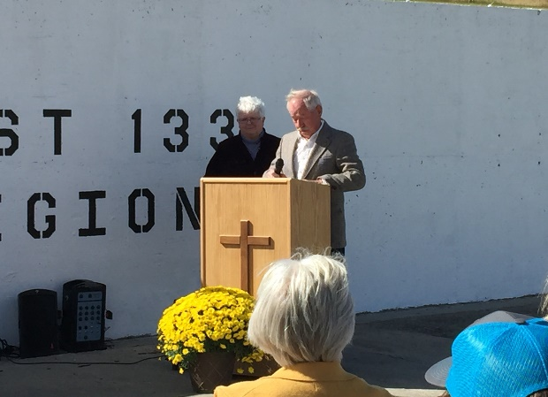
Commander Lewis Thoenes, Post 133, accepting marker with emcee Colleen Mason in background (Photo by Fred Shewman).
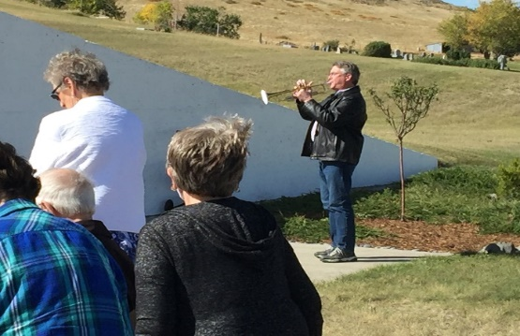Mr. Jeff Skogley playing Taps (photo by Fred Shewman).

