Petals newsletter, May 2020
Hello garden club members, I hope you all are surviving this pandemic. We have lots of postponements and cancellations to inform you about.

The MFGC Convention, scheduled for Havre has been postponed
We regret to inform everyone that we are postponing the MFGC Convention this year. The Bullhook Blossoms Garden Club and the MFGC Executive Board are not in favor of going forward due to the current Covid-19 pandemic. We are concerned for the health and well being of our members. The Havre club is willing to host it next year. More details will follow.

Earlier I had sent raffle tickets to the club presidents asking you to sell these for convention. However, with no convention in June, we ask that you keep selling these and send the money and tickets to Glenna Waltee, P. O. Box 662, Whitehall, MT 59759. We hope to draw for the quilt at Fall Board. You may bring your tickets and money to Fall Board if you do not want to mail them. Thank you for helping us with this fundraiser for MFGC. Here is a picture of the quilt. I am also attaching a picture of daffodils and tulips from my garden for this “Petals”.

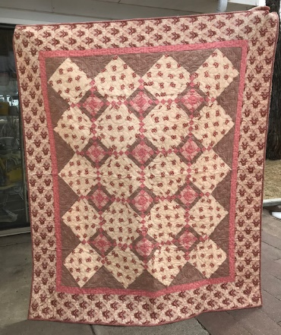
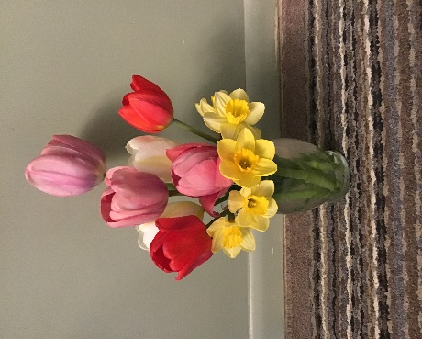

Landscape Design School moved to Sept 11-12
Joyce Hendricks, our Landscape Design School Chairman, would like to announce that Landscape Design School, which was supposed to be held in Billings on May 8-9, has been re-scheduled for September 11-12. Registration is due to Joyce by September 1. Forms can be found in the last MT Gardens and on the web. The ones on the web are updated.

Flower Show School Symposium has been postponed until next year
The Flower Show Symposium scheduled for July in Great Falls has been postponed until next year. Because of the corona virus, NGC is extending our expiring deadlines for a year. Dates will be scheduled for a later time.

Fall Board is Scheduled for October 9-10, Bozeman
Fall Board is still scheduled for Bozeman in October hosted by the Gallatin Empire Garden Club. Details are being worked out on where it will be held and if we can consider this our “annual meeting”. We will be letting you know when this information becomes available. Looking forward to seeing everyone in October, if the Covid-19 rules and regulations allow us to do so.

Endowment Grant News
We have some great news regarding the Endowment grant program offered by MFGC. It has been approved to award this grant two times a year, with winners announced at convention and fall board. Your club can receive up to $500 for your projects. I am attaching the grant information with this newsletter. The first applications are due June 1 and are available on the web also.

AWARDS Information
Myrna McCollum, awards chairman has reported that all award applications have been judged. Because we are not having convention, we will be mailing out the monetary awards for first place along with certificates to the presidents of the clubs. Myrna will be keeping the awards and scrapbooks because of mailing costs. She will bring them to Fall Board for you to pick up there. If you would like to get them earlier, Myrna has them at her house and you are welcome to stop by and pick up from her, 4413 Central, Great Falls, phone (406)452-1431. Thank you, Myrna and committee for all you hard work during this pandemic.

I know quite a few of your garden club meetings, flower shows, yard tours, etc have been cancelled or postponed during this crisis. Hopefully, we can get back to doing these activities soon. Our club and the Executive board have been having Zoom meetings to get our business done. Stay healthy and safe my gardening friends!

Happy Spring,
Sherry Corneliusen
MFGC President

