Petals in the Wind
MONTANA FEDERATION OF GARDEN CLUBS NEWSLETTER
FEBRUARY 2020

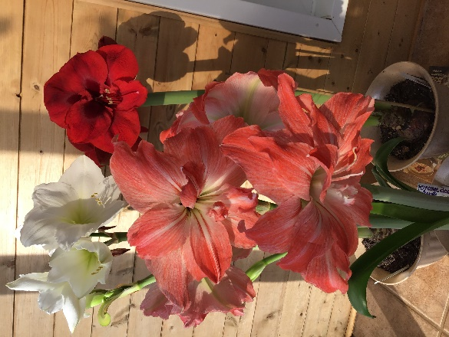

Hello garden club members, I hope you all are surviving the winter. We here in eastern Montana have had a fairly decent winter. However, last night we were minus 25 degrees, but then it is supposed to be nicer. The ground hog did not see his shadow, so I am hoping for an early spring. My amaryllis are all blooming and I am enjoying the beautiful vibrant colors.

Here are some upcoming meetings I would like you to mark on your calendars please.

District meetings times and places
April 15 – Eastern Gateway, Glendive, 9:30 am, Courthouse Community Room
April 16 – Hi-Line, Saco, 9 am, IOOF Hall
April 17 – Yellowstone, Big Timber, TBA
April 18 – Combined Western, Southwestern, Lewis & Clark – Whitehall, St Theresa Church
April 23 – Central, Great Falls, Christ United Methodist Church
April 24 – Northern, Chester, 9:30 am, Our Savior Lutheran Church
Your officers, 1st Vice President, Jim Sadler; 2nd Vice President, Diane Ward and myself will be traveling the state to attend these meetings and share information with you. We are looking forward to visiting with you.

MFGC Convention, June 11-14, Best Western Plus-Havre Inn & Suites
Please mark your calendars and plan to attend our convention to be held in Havre this year. The Bullhook Blossoms Garden Club has been busy planning and getting things organized for a great meeting. The theme is “20/20 Toni Hagener’s Vision”. Our Regional Director, Darla Anderson from Utah will be our guest. One of their tours is “Havre Beneath the Streets.” I am excited to do that. Registration forms will be in the next MT Gardens and on the web.

Save the Date, May 8-9, Landscape Design School
Joyce Hendricks, our Landscape Design School Chairman, would like to announce that Landscape Design School will take place in Billings on May 8-9, 2020. There will be 10 hours of course work and you should be done by 1:30pm so you can go nursery shopping. More information will be coming out in the Spring issue of Montana Gardens and will be on the web.

Save the date, July 17-18, Flower Show School Symposium
Great Falls Holiday Inn is the place for this school. We will study succulents and composite flowers. More information will be available in the spring Montana Gardens and on the web.

Club Reports
It has been a while since we have seen a club report in the Montana Gardens from some of your clubs. You need to do a club report for District meetings anyway, so why not send it to Patty Schlaeger at tamarackgroup@yahoo to be included in the Montana Gardens for one of the issues? I like to keep up with your activities and these reports also give us ideas we can incorporate into our own clubs. While you are at it, check out your club’s information on our website at mtfgc.org to make sure it is current.

Endowment Grants
After our MFGC finance committee meeting this spring, we may be announcing some news regarding the Endowment grant program offered by MFGC. Stay tuned for more details. I am attaching the grant information with this newsletter.

Membership Challenge
National Garden Clubs has challenged us to increase our membership by 21% by the year ’21.
I am attaching the “Join Us” newsletter from NGC that contains lots of ideas from other states on how to get new members. It mentions the Miles City Garden Club had gained quite a few new members. NGC did not get my email with the numbers but according to our treasurer, the Miles City Club had gained 17 new members, which figures about 35% increase! Great job Miles City Garden Club!!!!! Let’s all start working on gaining some new members.

Here is the report from Miles City on how they do it:
- Have a new member tea.
- Give out spring bulbs and have a contest on whose blooms first. Create an event out of it.
Give a prize for 1st, 2nd and 3rd place.
- Have business cards made with your club information on them and pass them out to everyone you talk to about a plant, a lawn mower, a garden, a recipe, any excuse at all.
- Advertise with posters on bulletin boards, libraries, grocery stores, etc.
- Put a want ad in the paper.
- Have a speaker and invite the public.
- Sponsor an entry at your local fair with a prize of a membership.
- Have a yard of the week program in summer and invite all the weekly winners. Choose a yard of the year out of those and give a membership to the winner.

PAT --- PLANT AMERICA with TREES
National Garden Clubs hopes that we can plant 165,000 trees in each year of the 2019-2021 administration. That is how many members belong to our national organization. It just takes “Each One” (member) to “Plant One” (native tree). I ordered a few bur oak, which are native to our state, and plan to plant them here in my yard. I also have some to share with my fellow garden club members. Are you planting your tree?

AWARDS
Due April 15
It is that time of year to be thinking about and getting your awards in to our chairperson, Myrna McCollum. Myrna and her committee have been working hard on revamping some of the awards and look forward to receiving many applications. All the award information and applications are on our website at mtfgc.org. Remember the deadline is April 15 and no late applications will be accepted. We sometime pick up awards on our District meeting trip, but not his year.
Send your applications to:
Myrna McCollum
4413 Central Ave
Great Falls, MT 59405-1643

We Need Your Help
We are looking for a club or district to volunteer to host our MFGC Convention in 2021 and also Fall Board 2021. Visit with your club members and let us know if you would consider being a host of one of these MFGC meetings. We would love to come to your town.

Happy Gardening,
Sherry Corneliusen
MFGC President

